**Phase 9: Reporting, Dashboards & Security Review**

1. **Reports**
   * App Launcher → Reports → New Report.
   * Choose “Donors with Food Donations”.
   * Create:
     + **Tabular** → List all donations.
     + **Summary** → Group by NGO.
     + **Matrix** → Group by Donor vs NGO.

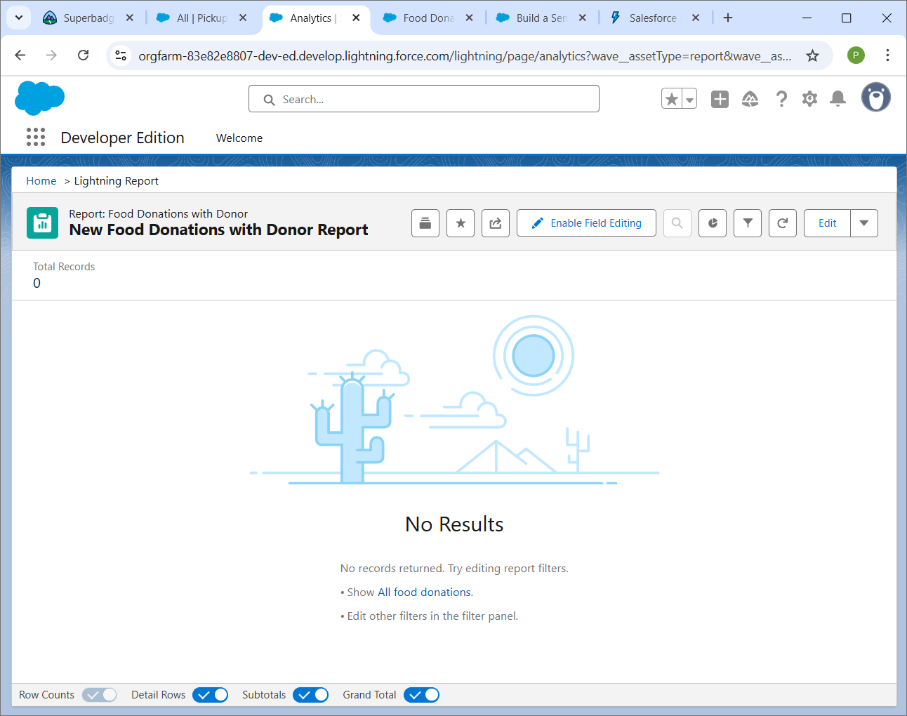

1. **Dashboards**
   * App Launcher → Dashboards → New Dashboard.
   * Add report charts (Pie chart: Donation Type, Bar chart: NGO-wise).

1. **Dynamic Dashboard**
   * In Dashboard Settings → “Run as logged-in user”.
   * Test: Admin sees all, NGO sees only their data.
2. **Sharing Settings**
   * Setup → Sharing Settings → Change OWD for Food Donation = Private.
   * Create Sharing Rule → “NGO role can see assigned donations”.

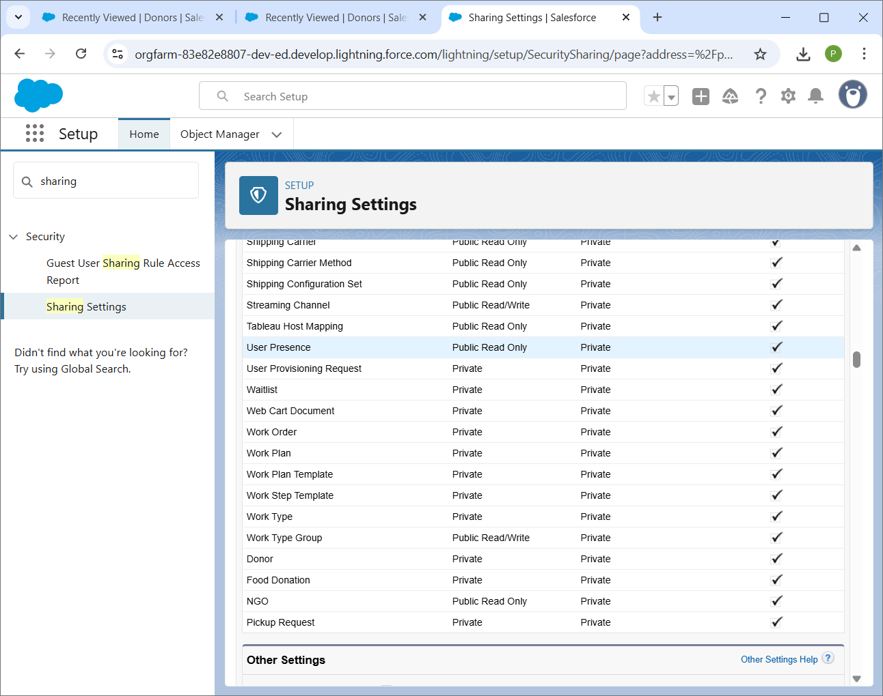

1. **Field Level Security (FLS)**
   * Setup → Object Manager → Donor → Fields → Phone → Set Field-Level Security → Hide for NGO Profile.

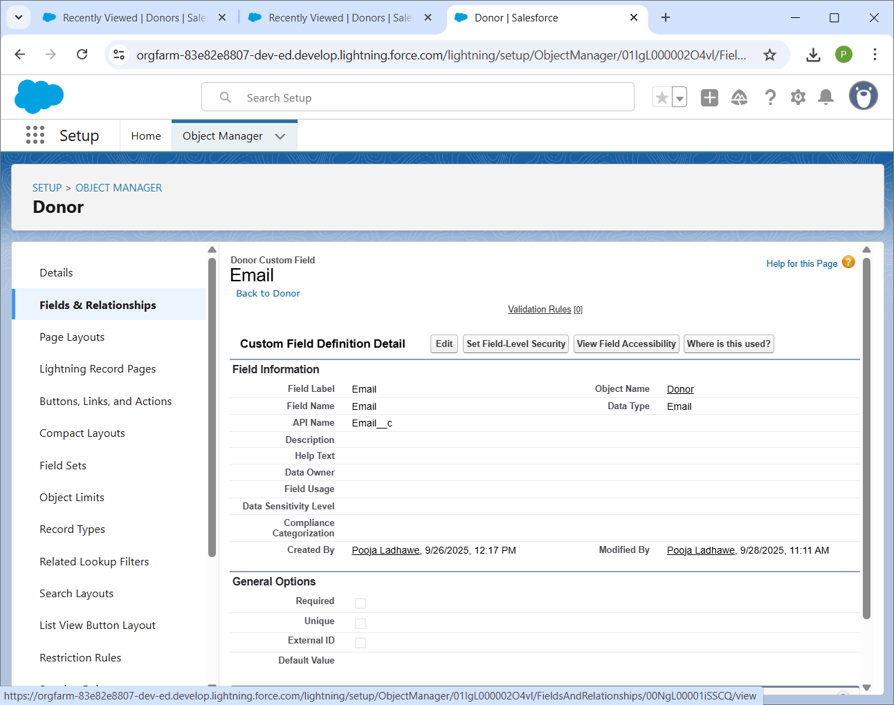

1. **Login IP Ranges**
   * Setup → Profiles → Select NGO Profile → Add Login IP range (like 192.168.x.x).

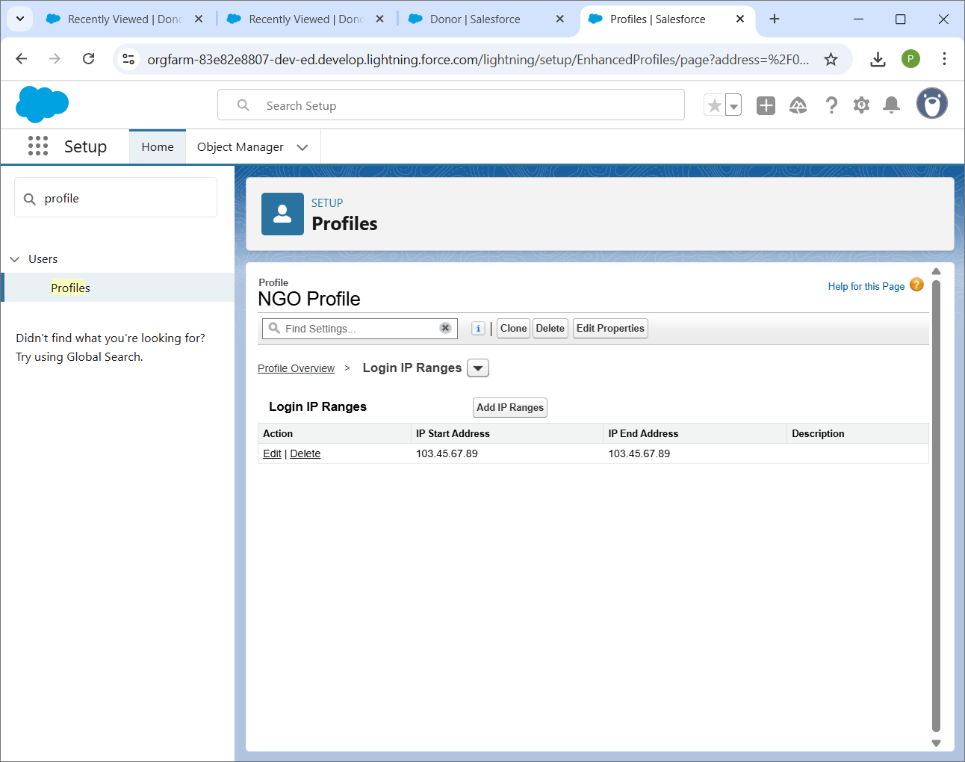

1. **Audit Trail**
   * Setup → View Setup Audit Trail.
   * See who changed what (last 6 months).

